HW 3
Note: g = 10 m/s²
1 | 2 | 3 | 4 | 5 | 6 | 7 | 8 | 9 | 10 | 11 | 12 | 13 | 14 | 15 | 16 | 17 | 18
- The Si unit of torque is
a) N. m b) N.m² c) N.m/s d) N.s
- A system consists of three particles, each of mass m and located at (1,1), (2,2) and (3,3). The co-ordinates of the center of mass are
a) (1,1) b) (2,2) c) (3,3) d) (6,6)
- The distance between a carbon atom (m=12 u) and an oxygen atom (m=16 u) in the CO molecule is 1.12 A⁰. How far from the carbon atom is the center of mass of the molecule?
a) 6.5x10⁻¹¹ m b) 5.2x10⁻¹¹ m c) 4x10⁻¹¹ m d) 1x10⁻¹¹ m
- Three cubes, of sides ℓ₀, 2ℓ₀, and 3ℓ₀ are placed next to one another (in contact) with their centers along a straight line. What is the position, along this line, of the CM of this system? Assume the cubes are made of the same uniform material.
a) 5.5 ℓ₀ b) 3.5 ℓ₀ c) 4.5 ℓ₀ d) 2.5 ℓ₀
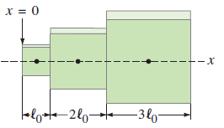
- Find the center of mass of the three-mass system shown relative to the 1.00-kg mass.
a) - b) - c) - d) -
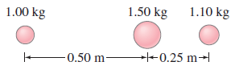
- The x and y coordinates of the center of mass of the three-particle system shown below are:
a) 1.3m, 1.7m b) 1.4m, 1.9m c) 1.9m, 2.5m d) 0, 0

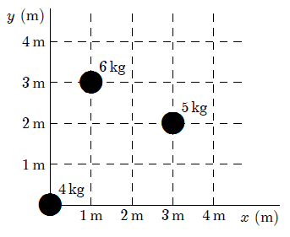
- Two blocks, each of mass m, are attached to the ends of a massless rod which pivots as shown. Initially the rod is held in the horizontal position and then released. Calculate the magnitude and direction of the net torque on this system when it is first released.
a) - b) - c) - d) -
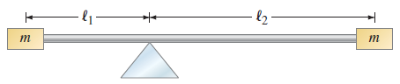
- An 80-N uniform plank (لوح خشبي) leans (يتكئ) against a frictionless wall as shown. The magnitude of the torque (about point P) applied to the plank by the wall is:
a) 40 N.m b) 60 N.m c) 120 N.m d) 160 N.m
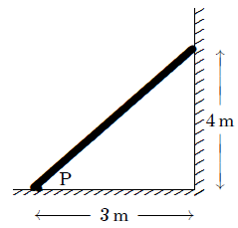
- A 5.0-m weightless strut (دعامة), hinged to a wall, is used to support an 800-N block as shown. The horizontal and vertical components of the force of the hinge on the strut (F_{h},F_{y}) (in N) are:
a) (800,800) b) (600,800) c) (800,600) d) (1200,800)
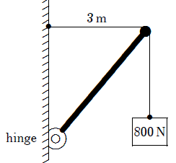
- Stress can be measured in:
a) N/m² b) N·m c) N.m² d) N².m²

- A certain wire stretches 0.90 cm when outward forces with magnitude F are applied to each end. The same forces are applied to a wire of the same material but with three times the diameter and three times the length. The second wire stretches:
a) 0.10 cm b) 0.90 cm c) 0.30 cm d) 2.7 cm
- A force of 5000N is applied outwardly to each end of a 5.0-m long rod with a radius of 34.0 cm
and a Young’s modulus of 125 × 10⁸ N/m². The elongation of the rod is:
a) 0.0020 mm b) 0.0040 mm c) 0.14 mm d) 0.55 mm

- A cube with edges exactly 2 cm long is made of material with a bulk modulus of 3.5×10⁹ N/m².
When it is subjected to a pressure of 3.0 × 10⁵ Pa its volume is:
a) 7.31 cm³ b) 7.99931 cm³ c) 8.00069 cm³ d) 8.69 cm³
- A cube with 2.0-cm sides is made of material with a bulk modulus of 4.7 × 105 N/m². When it is subjected to a pressure of 2.0 × 10⁵ Pa the length of its any of its sides is:
a) 0.85 cm b) 1.15 cm c) 1.66 cm d) 2.0 cm

- A shearing force of 50 N is applied to an aluminum rod with a length of 10 m, a cross-sectional area of 1.0 × 10⁻⁵ m, and a shear modulus of 2.5 × 10¹⁰ N/m². As a result, the rod is sheared through a distance of:
a) zero b) 2 mm c) 2 cm d) 19 cm

- A nylon string on a tennis racket is under a tension of 275 N. If its diameter is 1.0 mm, by how much is it lengthened from its untensioned length of 30.0 cm?
a) zero b) 0 c) 0 d) 0

- A marble column (عمود رخام) of cross-sectional area 1.4 m² supports a mass of 25,000 kg.
(a) What is the stress within the column? (b) What is the strain?

- A 15-cm-long tendon (وتد) was found to stretch 3.7 mm by a force of 13.4 N. The tendon was approximately round (مستدير) with an average diameter of 8.5 mm. Calculate Young’s modulus of this tendon.

