Introduction to Organic Chemistry
For None-Chemistry Students
PART ONE
Classification and Naming

What is meant by “Organic”?
Organic literally means “derived from living organisms” — organic chemistry was originally the study of compounds extracted from living organisms and their natural products.
Chemicals extracted from plants and animals were originally called “organic” because they came from living organisms

What is Organic Chemistry?
Organic chemistry is concerned with the study of the structure and properties of compounds containing carbon. All organic compounds contain carbon atoms. It was believed that only living organisms could create organic compounds. This concept has been changed in 1828 after urea, NH₂CONH₂ (organic compound) was prepared in the laboratory.

What is special about Carbon?
1. Carbon atoms form stable bonds to many other elements like H, O, N, S, P, F, Cl, Br, I, . . . . In addition to carbon itself. Most organic compounds contain hydrogen, and sometimes oxygen, nitrogen, sulfur, phosphorus, etc.
2. Due to the nature of carbon atom and its bonding variety and complexity, it can form complex structures, such as long chains, branched chains, rings, complex 3D structures, etc. Therefore, more than 15,000,000 organic compounds are known, compared to about 500,000 known inorganic compounds.
3. Organic chemistry is basic in life science. Carbohydrates, vitamins, enzymes, proteins, fats, lipids, DNA, RNA and many more are all biologically active organic compounds.
4. Organic chemistry and organic compounds are extremely important in medicine, food, agriculture, fertilizers, fuel, petroleum, paints, plastics, rubbers, textiles, …., . Actually, all of these and much more, never stand without carbon. NO CARBON NO LIFE.

Chemically speaking:
The chemical bonds formed by carbon occur by the use of its hybrid orbitals, which are formed by mixing (hybridizing) the atomic orbitals.
sp³ hybridization: carbon is bonded to 4 other atoms. (mixing of the 2s and the 3 orbitals of 2p), the geometric shape around the sp³ carbon is tetrahedral, (3D structure).

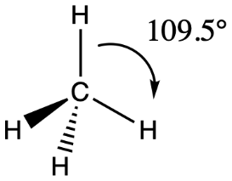 | 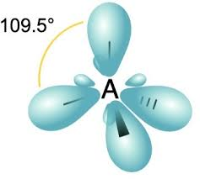

Sp² hybridization: carbon is bonded to 3 other atoms. (mixing of the 2s and 2 orbitals of 2p), the geometric shape around the sp² carbon is planar triangular, (2 D structure).
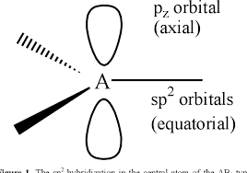 | 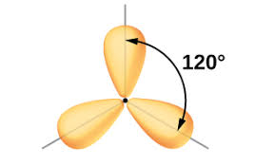

sp hybridization: carbon is bonded to 2 other atoms. (mixing of the 2s and 1 orbital of p), the geometric shape around the sp carbon is linear.

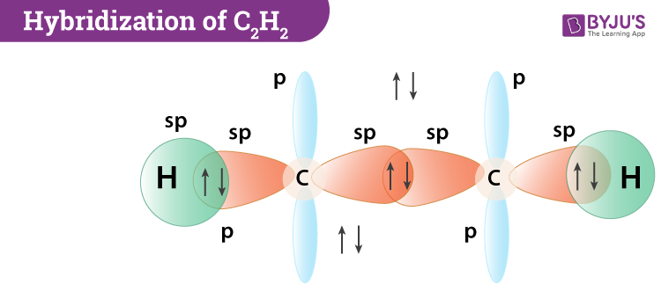 | 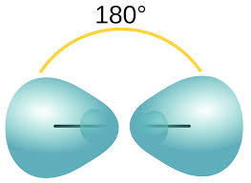

Sigma (σ) and Pi (π) bonds:

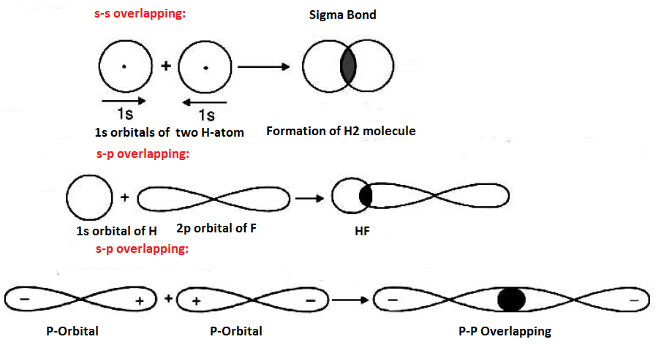

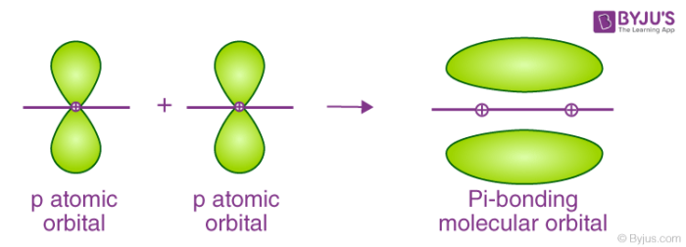
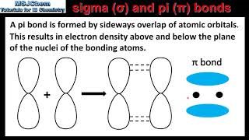
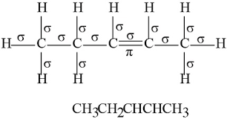
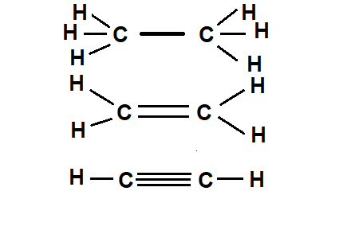 | Carbon/carbon bonds  All are σ bonds
 | one σ , one π
 | one σ , two π

Sigma bonds are stronger than pi bonds.

When carbon is bonded to 4 other atoms, all bonds formed are single, and 3D saturated structures are formed.
Double bonds are formed when carbon is bonded to 3 other atoms. (alkenes)
Triple bonds are formed when carbon is bonded to 2 other atoms. (alkynes)
Double and triple bonds are called multiple bonds. Organic compounds with multiple bonds are called unsaturated.

Isomers:
They are compounds having identical molecular formulas, but with different arrangements of atoms. The atoms in each molecule are connected in a different order. This type of isomers is called structural isomers. There are other types of isomers which are not important to us now.
Example: C₂H₆O would be ethyl alcohol or dimethyl ether.

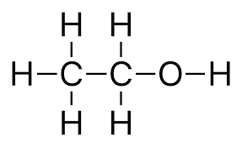 | 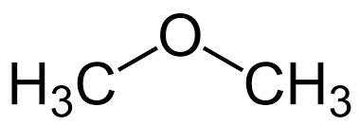
Ethyl alcohol | Dimethyl ether

Example: C₃H₆O would be acetone or propyl aldehyde. We will see more examples later.

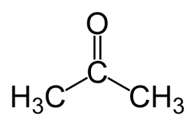 | 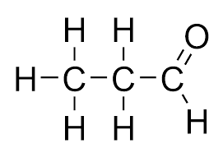
Acetone | Propyl aldehyde

Functional Groups:
Functional group is defined as a collection of atoms of certain characteristic arrangement that defines the chemical and physical properties of certain class of organic compounds.
Hydrocarbons contain the simplest functional groups. They contain only carbon and hydrogen. They include alkanes, alkenes, alkynes, and aromatic hydrocarbons.
Functional groups that contain oxygen atoms, like alcohols, ethers, aldehydes, ketones, carboxylic acids, and esters. Other functional groups contain nitrogen atoms, like amines and amides. Organic compounds are classified according to their functional groups.

PART ONE:

Classification and Naming of Organic Compounds
Based on their functional groups, organic compounds may contain the following categories:
I. Hydrocarbons:
A hydrocarbon is an organic compound consisting entirely hydrogen and carbon.
Generally, hydrocarbons are colorless compounds. They can be gases (like methane and propane), liquids (like hexane and benzene), low melting-point solids or waxes (like paraffin wax).
Hydrocarbons may be aromatic or none-aromatic. None-aromatic are also called aliphatic.
Hydrocarbons may be saturated or unsaturated.

Classification of Hydrocarbons:
1. Saturated hydrocarbons:
They are composed entirely of single bonds. They are called alkanes. They would be:
i) Acyclic, with a general formula of CnH2n+2 , "n" is the number of carbon atoms.
ii) Cyclic, called cycloalkanes, with a general formula of CnH2n when are with one ring only.
2. Unsaturated hydrocarbons:
i) Alkenes: contain one double bond or more. The general formula is CnH2n if they are acyclic
and have one double bond only.
ii) Alkynes: contain one triple bond or more. The general formula is CnH2n-2 if they are acyclic and have one triple bond only.

The first ten aliphatic (-ane, -ene, -yne) hydrocarbons are listed below:

# of carbon atoms | Alkane  C_{n}H_{2n+2} | Alkene  C_{n}H_{2n} | Alkyne  C_{n}H_{2n-2} | Cycloalkane  C_{n}H_{2n}
1 | Methane | ----- | ---- | -----
2 | Ethane | Ethene (ethylene) | Ethyne (acetylene) | -----
3 | Propane | Propene (Prppylene) | Propyne | cyclopropane
4 | Butane | Butene (Butylene) | Butyne | cyclobutane
5 | Pentane | Pentene | Pentyne | cyclopentane
6 | Hexane | Hexene | Hexyne | cyclohexane
7 | Heptane | Heptene | Heptyne | cycloheptane
8 | Octane | Octene | Octyne | cyclohctane
9 | Nonane | Nonene | Nonyne | cyclononane
10 | Decane | Decene | Decyne | cyclodecane
The above table is illustrated by the example below:

 | 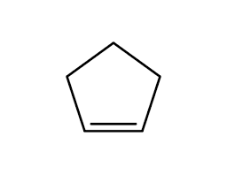
Pentane | cyclopentene, C₅H₈
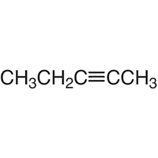 | 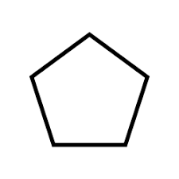
2-pentyne, C₅H₈ | Cyclopentane, C₅H₁₀

Hydrocarbons are represented in different ways:
a) Structural formula: it shows how atoms are bonded to each other.
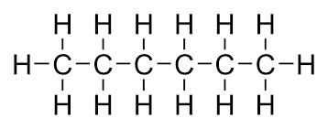

b) Condensed formula:
Example:
The condensed form of n-hexane is: CH₃CH₂CH₂CH₂CH₂CH₃ or CH₃(CH₂)₄CH₃
Example: n-butane
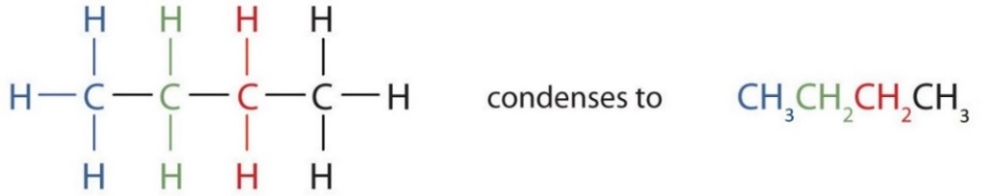
c) Line-angle formula:
Carbons are at the ends and at the corners, with the correct number of hydrogens.
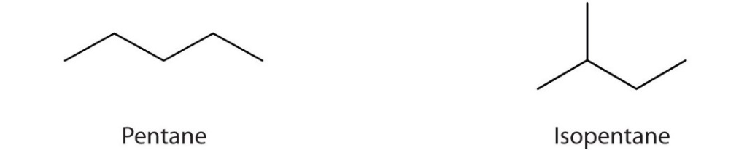

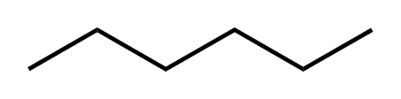 | CH₃CH₂CH₂CH₂CH₂CH₃
Angle-line formula | Condensed formula
n-hexane

d) Closed formula: shows the number of atoms of each element in a molecule. The closed
formula of the butane and hexane are C₄H₁₀ and C₆H₁₂ respectively.

3. Aromatic hydrocarbons (Also known as Arenes):
As we know, aromatic compounds are those that contain the benzene ring, C₆H₆, or its structural derivatives. (remember the Kekulé structures, resonance, C₆H₆ ….)

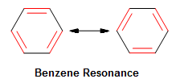 | OR | 

More Examples on Aromatics:

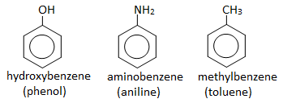

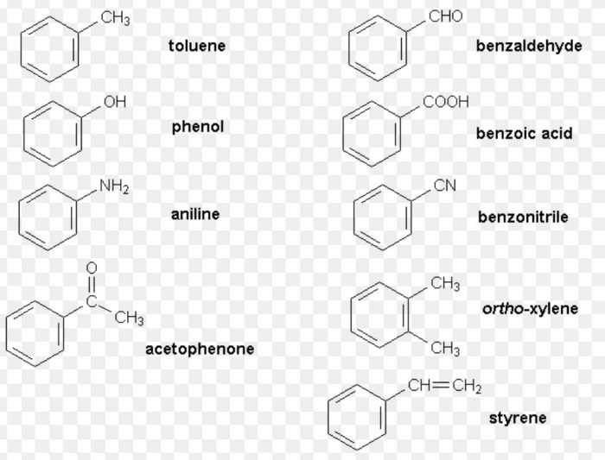

Alkyl groups:
Alkanes with no branches are called normal alkanes, denoted by the letter n-. Examples are shown in the table above. Branches on hydrocarbons are called alkyl groups and denoted by the letter R–. Examples on the most common alkyl groups are shown below:

Group | R− | CH₃– | CH₃CH₂– | CH₃CH₂CH₂– | (CH₃)₂CH– | 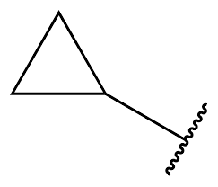
Name | Alkyl | Methyl | Ethyl | Propyl | Isopropyl | Cyclopropyl

Group | CH₃CH₂CH₂CH₂– | CH₃CHCH₂CH₃ | (CH₃)₂CHCH₂– | (CH₃)₃C–
Name | n-Butyl | sec-butyl | Isobutyl | tert-butyl

Structures of some of the alkyl groups are shown below:
-
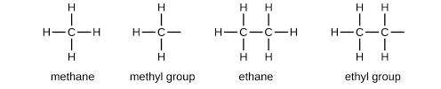
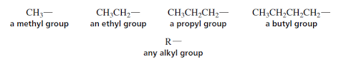
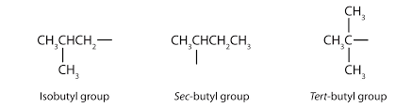

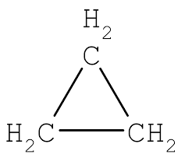 |  | 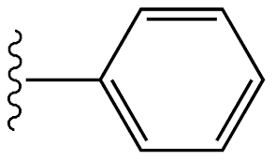
Cyclopropane | Cyclopropyl group | Phenyl group

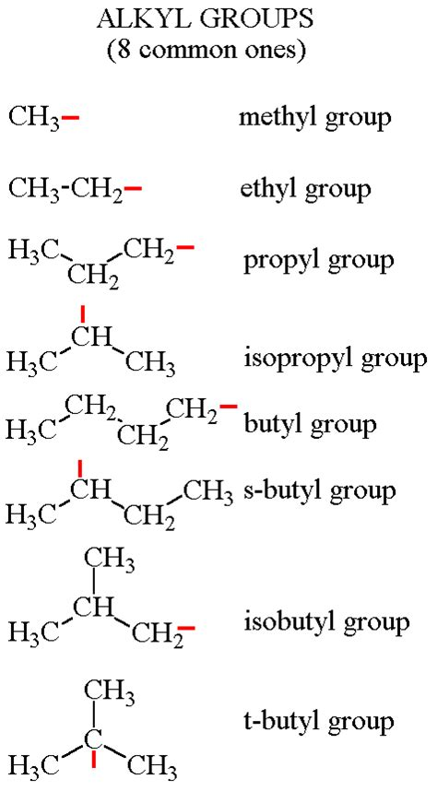 t-tertiary s-secondary

Acyl and acetyl groups:
Acetyl group is a special case of acyl group where the alkyl group of the aceyl (R‒) is a methyl group in acetyl. These groups have carbonyl carbon connected the alkyl group as shown below:
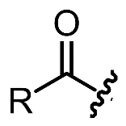 | 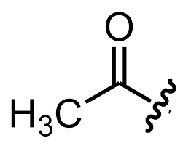
Acyl group | Acetyl group (it is acyl with R=methyl)

Phenyl, benzyl and benzoyl groups:

 | 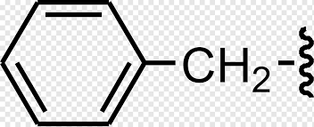 | 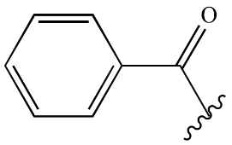
Phenyl group | Benzyl group | Benzoyl group

IUPAC (International Union of Pure and Applied Chemistry) rules for naming hydrocarbons:
1. Identify the longest carbon chain. This chain determines the parent name of the alkane.
2. If there are two choices of the same length, then the parent chain is the longest chain that has
the greatest number of “branches”.
3. Number the carbons on the chain beginning at the end that is closest to any of the branches
(substituents), thus ensuring the lowest possible numbers for positions of substituents.
4. Use these numbers to designate the location of the substituent groups (branches).
5. Prefixes like di−, tri−, tetra−, penta− , . . . will also be used in naming compounds with same
type of substituent.

Examples:
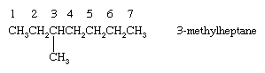
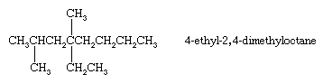

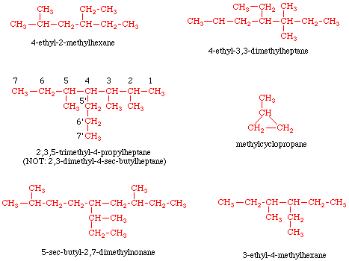

The sum of the substituents' positions should be the smallest (lowest sum rule).
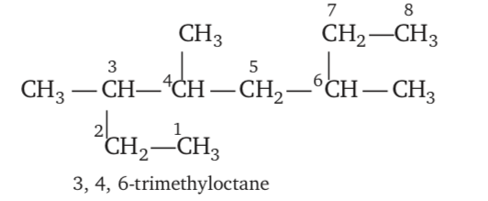
Or : 3,5,6 (the other option above)

Alkenes and Alkynes:

IUPAC (systematic) System naming of Alkenes
- The longest carbon chain containing the carbon-carbon double bond is selected as the parent alkene.
- The suffix ‘ane’ of the alkane is replaced by ‘ene’.
- If a double bond occurs twice or thrice in the parent chain the alkene is called diene or triene, respectively.
- The longest chain is numbered starting from the end which gives the lowest number to the carbon atom of the double bond and that number is written just before the suffix ‘ene’.
- If while numbering the chain the double bond gets the same number from either side the carbon chain is numbered in such a manner that the substituent gets the lowest number.
- In case there are two or more double bonds, the lowest sum rule should be followed.
- The names and positions of other groups (substituents) are indicated by prefixes.

Examples on alkenes:
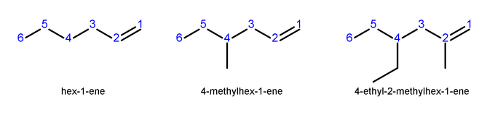
1-hexene | 4-methyl 1-hexene | 4-ethyl-2-methyl-1-hexene


2-methyl-1-butene


2-methyl-2-butene


3-methyl-2-heptene

More Examples on Alkenes:
 | 1-pentene
CH₃–CH=CH–CH₂–CH₃ | 2-pentene
CH₃CH₂CH=CHCH₂CH₃ | 3-hexene
CH₃–CH₂–CH=CH–CH₂–CH₂–CH₃ | 3-heptene
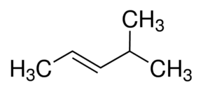 | 4-methyl-2-pentene

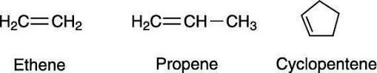
Geometric isomers:
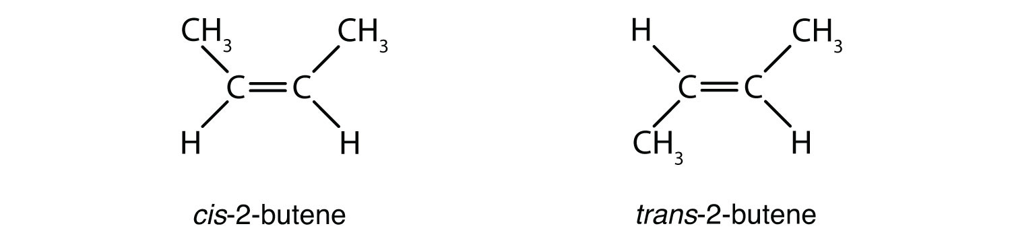
There are some other types of isomers, but not of importance to us in this course.
H.W: draw the structure of 4-methyl 2,6-octadiene?

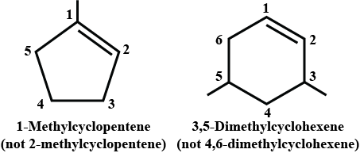

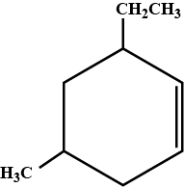 | 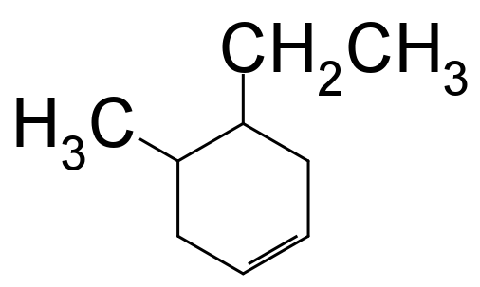
3-ethyl-5-methylcyclohexene | 4-ethyl-5-methylcyclohexene

Two groups with double bond that are common in naming hydrocarbons:
- H₂C=CH– Vinyl group
- H₂C=CH–CH₂– Allyl group

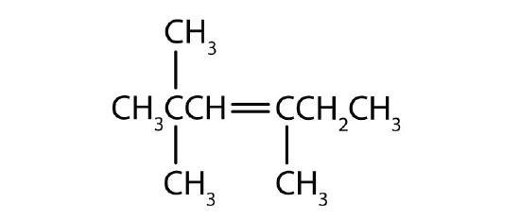
2,2,3-trimethyl-3-hexene

Examples on alkynes: (C_{n}H_{2n-2})

Ethyne (Acetylene)
Propyne (C₃H₄)
1-Butyne (C₄H₆)
2-Butyne (C₄H₆)
2-pentyne (C₅H₈)


3-methyl-1-hexyne
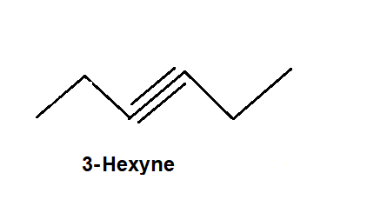 | 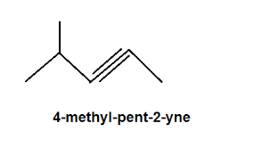
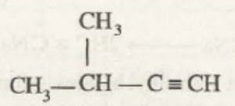 | 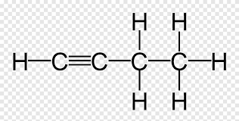
3-methyl butyne | butyne
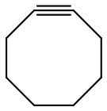 | 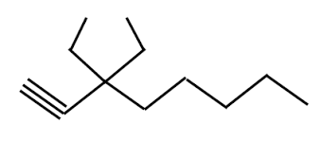
cyclooctyne | 3,3-diethyl-1-octyne

Organic compounds may contain any combination of double and triple bonds, with or without cyclic structures. ….

Examples on aromatic hydrocarbons:

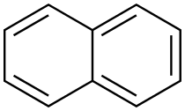 | 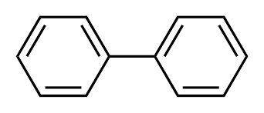
Naphthalene | Biphenyl
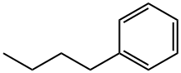 | 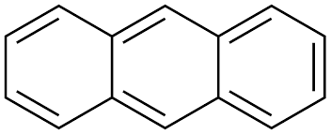
n-butyl benzene | Anthracene
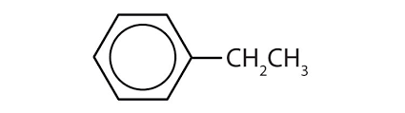 | 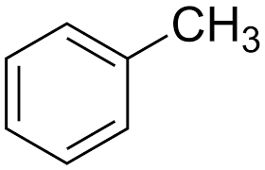
Ethyl Benzene | Toluene

Examples on aromatic compounds with elements other that carbon and hydrogen:
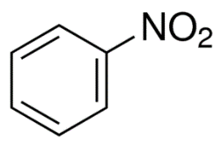 | 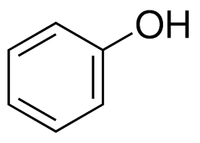 | 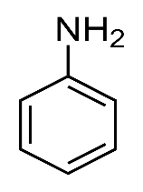 | 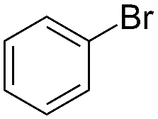
Nitrobenzene | Phenol | Aniline | Bromobenzene  Or phenyl bromide

II. Organic Compounds with Functional Groups containing elements other than Hydrogen and Carbon:
This category of organic compounds contains other elements besides carbon and hydrogen. These elements are like oxygen, nitrogen, sulfur and halides (F, Cl, Br, I). A collection of some types of atoms together in certain way in a molecule of a compound makes that compound chemically and physically behave in certain way. This collection of atoms is called functional group. Examples on functional groups are shown below:

A. Halide-containing functional groups:
Alkyl halides may have common names or IUPAC names. The common names of alkyl halides consist of two parts: the name of the alkyl group plus the root of the name of the halogen plus the ending -ide. The IUPAC way of naming uses the name of the parent alkane with a prefix indicating the halogen substituents, preceded by number indicating its location. Usually, common names are used with small alkyl halides (up to 4 carbon atoms). IUPAC names are used with larger molecules. For example, the common name of CH₃CH₂Cl is ethyl chloride and its IUPAC name chloroethane.
As a substituent (or a group) on the alkane chain, the halogens are named as shown in the list below:
Name: | Fluro− | Chloro− | Bromo− | Iodo−
Group: | F− | Cl− | Br− | I−

The general form of the alkyl halide is R−X, where X is one of the halide substituents.

Examples on Alkyl Halide:

2-bromo pentane

2-chloro-3-methyl-butane

1-bromo-2-chloro 4-methyl-pentane

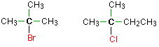
2-bromo-2-methyl propane 2-chloro-2-methyl butane
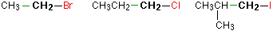
1-Bromo ethane 1-Chloro propane 1-iodo-2-methyl- propane
(Ethyl bromide) (propyl chloride)
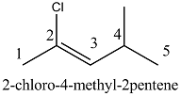
Note: alphabetical order of the substituents.

B. Oxygen-containing functional groups:
The most common oxygen-containing functional groups are mentioned below:
(ketal, acetal, … and others are examples that are not mentioned).

# | Functional Group | Naming | Comments
1 | Alcohol: R−OH, R2−OH, R3−OH | − ol | 1o, 2o and 3o
2 | Ether, R−O−R | Alkyl ether
3 | Aldehyde R−COH | − al
4 | Ketone R−CO−R | − one
5 | Carboxylic acid, R−COOH | − oic acid
6 | Ester, R−(CO)−O−R | alkyl alkanoate

1. Alcohols: (Alkan-ol; or Alkanediol, …)
The hydroxyl group -OH is the functional group for alcohols and phenols. In alcohols, it is connected to an alkyl carbon where as in phenols it is connected to benzene ring (aromatic).
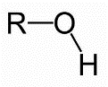 | 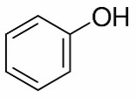
Alcohol | Phenol

Naming of Alcohols:
1. Identify the longest chain to which the hydroxyl (—OH) group is attached.
2. Name this chain by dropping the -e at the end of the name of the hydrocarbon parent and add -ol.
3. Number the longest chain carbons to give the lowest possible number to the carbon bearing the
hydroxyl group, and identify the carbon numbers of other substituents.
4. If there is more than one OH group add the prefix (di-, tri-, tetra-, etc.) immediately in front of the
suffix -ol. (diol, triol, tetraol, etc.). The “- e” of the parent hydrocarbon is not dropped. Positions of
each alcohol group is indicated by carbon number, separated by commas. (e.g.: 1,3- pentanediol).

Examples:


2-propanol 2º alcohol

2-pentanol 2º alcohol

2-methyl-2-propanol 3º alcohol

Cyclohexanol

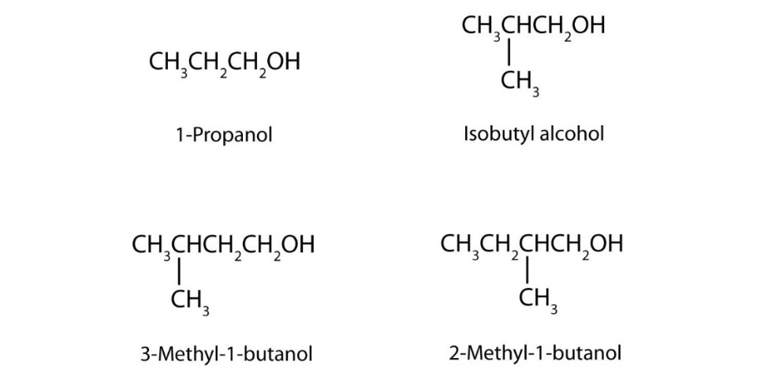

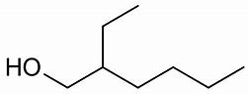 | 2-ethyl-hexanol 1o alcohol
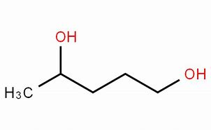 | 1,4-pentanediol
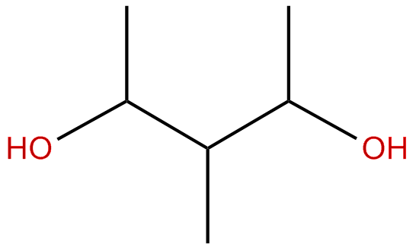 | 3-methyl-2,4-pentanediol

2. Ethers:
Ether may be symmetric (with two identical groups around oxygen) or asymmetric (with two different groups around oxygen). Ethers have common names and IUPAC names.
I) Common Names:
Naming the alkyl or aryl groups around oxygen in alphabetical order, then add the word "ether". For symmetrical ethers the -prefix "di" is used before the name of the alkyl/aryl group. The "di" also may be omitted. Diethyl ether for example would be ethyl ether.

II) IUPAC Nomenclature: (Alkoxy alkane);
▪ The substituent group containing more carbon atoms is chosen as parent hydrocarbon, (alkane).
▪ The other substituent group attached to the oxygen atom is named with a prefix “oxy”, (alkoxy)
Examples:
Dimethyl ether Or Methyl ether
IUPAC: Methoxy methane
Ethyl methyl ether
IUPAC: Methoxy ethane
Ethyl ether. (diethyl ether)
IUPAC: Ethoxy ethane
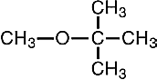 | t-butyl methyl ether  IUPAC: 2-methoxy 2-methyl propane

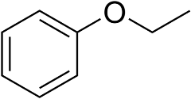 | Ethyl phenyl ether  IUPAC: Ethoxy benzene
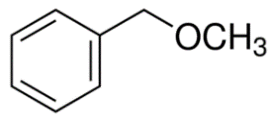 | Benzyl methyl ether  Methoxy methyl benzene
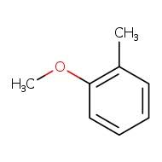 | Benzyl methyl ether  Methoxy-2-methyl benzene

3. Aldehydes (alkan-al) link 1
Nomenclature of Aldehydes:
▪Select the longest chain that contains the carbonyl carbon.
▪Replace the -e ending of the parent alkane by the suffix -al.
▪The carbonyl carbon is always numbered “1.” (It is not necessary to include the number in the name)
▪Name the substituents attached to the chain in the usual way.

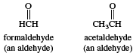 |  | Methanal (Formaldehyde)  Ethanal (Acetaldehyde)
 | 
 | Propanal

 | 
 | Butanal
 | 
 | 2-methyl pentanal
 |  |  | 2-methylprpanal
 | 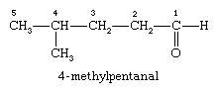
 | 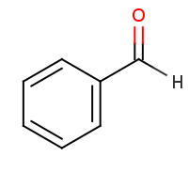 | Benzaldehyde
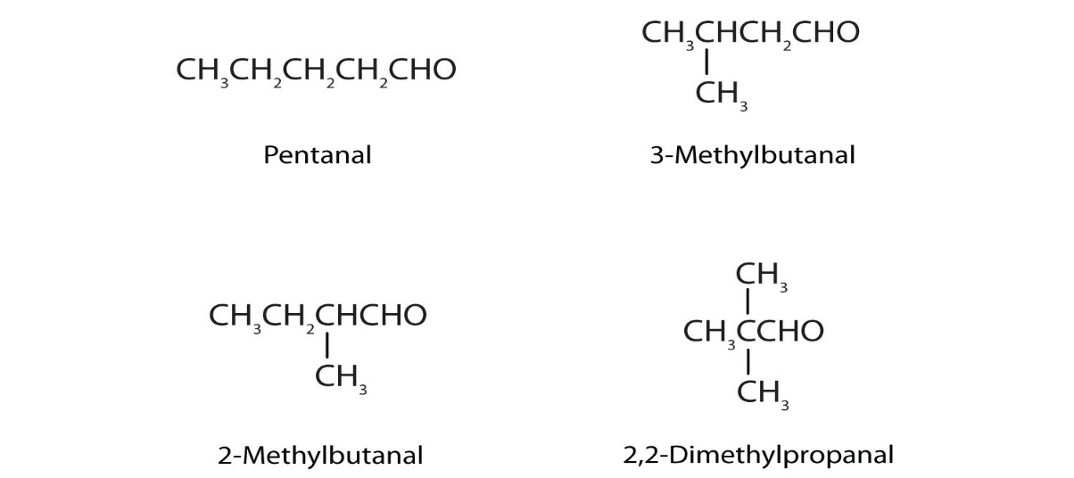

4. Ketones (link 1 link 2) (Alkan-one)
Nomenclature of Ketones:
I) Common Name:
Mentioning the groups around the carbonyl group.
II) IUPAC Name:
▪Select the longest carbon chain containing the carbonyl carbon.
▪Replace the -e ending of the parent alkane name by the suffix -one.
▪Number the chain starting with the end closest to the ketone group (the carbonyl carbon should
have the lowest possible number). The location number for the ketone group precedes the name
for the longest chain.
▪Name the substituents attached to the chain in the usual way.

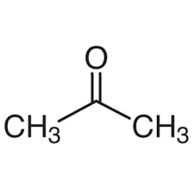
2-propanone (Acetone)

3-Pentanone (diethyl ketone)


2-hexanone OR butyl methyl ketone

OR 2-butanone

3-hexanone OR Ethyl propyl ketone


4-heptanoe OR dipropyl ketone

3-methyl-2-butanone OR methyl isopropyl ketone

3-heptanone OR Butyl ethyl ketone


2,5-dimethyl-3-pentanone OR diisopropyl ketone

2-methyl-3-hexanone OR isopropyl propyl ketone

4-methyl-3-hexanone OR ethyl isobutyl ketone


Cyclobutanone

Cyclohexanone
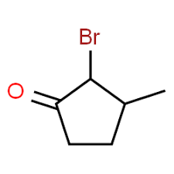
2-bromo-3-methyl cyclopentanone
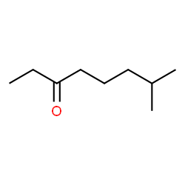 | 7-methyl-3-octanone

5. Carboxylic Acids: (alkan-oic acid) Link: More examples (Carboxylic acids):

Nomenclature of Carboxylic Acids
▪Select the longest carbon chain including the carboxyl carbon to be the parent alkane.
▪The -e ending of the parent alkane name is replaced by the suffix -oic acid.
▪The carboxyl carbon is always numbered “1” but the number is not included in the name.
▪Name the substituents attached to the chain in the usual way.
If there are other substituents present in the parent chain, then the numbering is done to give the substituents the lowest number at the first point of difference
Aromatic carboxylic acids (i.e., with a -CO₂H directly connected to a benzene ring) are named after the parent compound, benzoic acid.

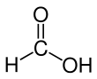 | Methanoic acid  (Formic acid)
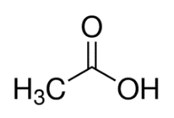 | Ethanoic acid  (Acetic acid)

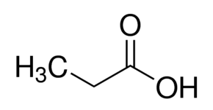 | Propanoic acid
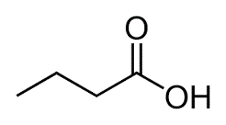 | Butanoic acid
 | 3-methyl butanoic acid
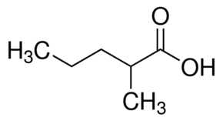 | 2-methyl pentanoic acid
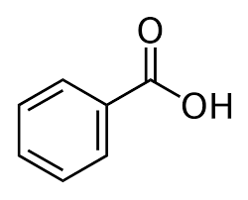 | Benzoic acid  Benzenecarboxylic acid  Carboxybenzene phenylformic acid
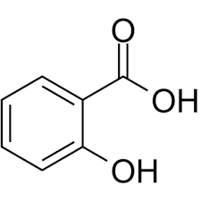 | Salicylic acid  Ortho-hydroxy benzoic acid  (NOTE: there are other names)

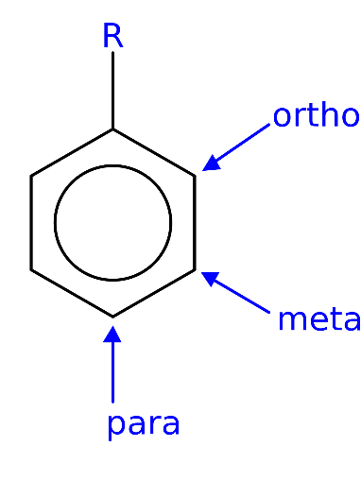

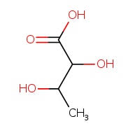 | 2,3-dihydroxy butanoic acid
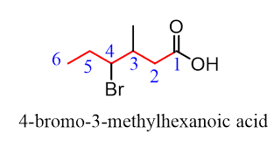

6. Esters: Alkyl alkanoate
Alkyl: The group connected to the oxygen.
Alkanoate: Started with the carbonyl carbon (the carbonyl carbon is included in this part of the name).

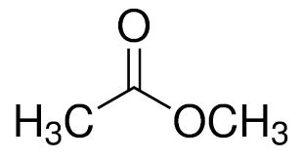 | Methyl ethanoate
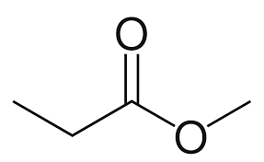 | Methyl propanoate
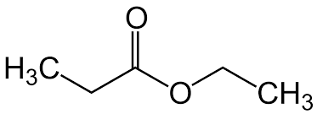 | Ethyl propanate
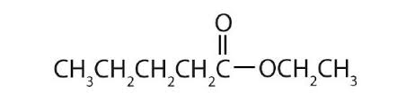 | Ethyl pentanoate

CH₃COOCH₂CH₂CH₂CH₂CH₂CH₂CH₂CH₃  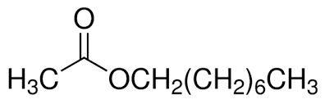 | Octyl ethanoate
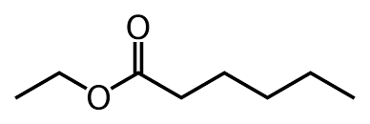 | Ethyl hexanoate
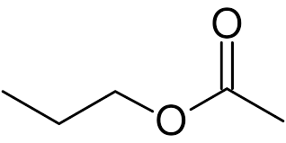 | Propyl ethanoate
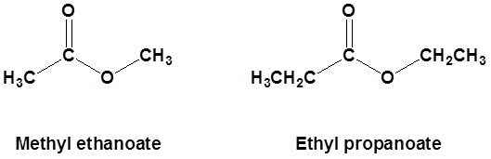

More examples Link (Esters):

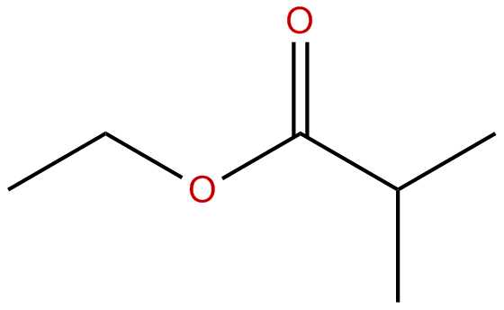 | Ethyl-2-methyl propanoate
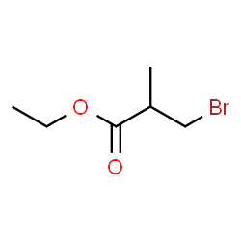 | Ethyl-3-bromo-2-methyl propanoate

C. Nitrogen-containing functional groups:
As shown in the list below these functional groups contain oxygen besides the nitrogen. Also, only the most common ones are mentioned here.
# | Functional Group | Name | Comment
1. | Amine, R−NH2, R2−NH, R3−N | − amine | 1o, 2o, 3o
2. | Amide, R−(CO)−N−R2 | − amide | 1o, 2o, 3o
There are many other nitrogen-containing functional groups like imides and others. They are out of the scope of this introduction.
Amines:
Amines are the derivatives of ammonia (NH₃).
Depending on the number of alkyl groups connected to nitrogen, they are classified as primary, secondary and tertiary. The general structure is shown below:

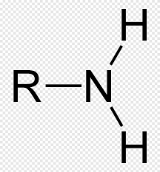 | 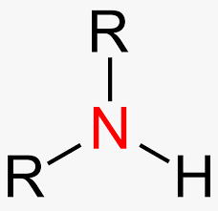 | 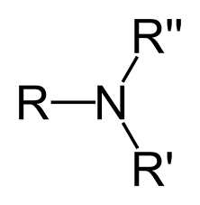
1º Amine | 2º Amine | 3º Amine
The Substituent groups may be different or equivalent, or may be aliphatic or aromatic.
Naming of amines:
- The IUPAC system: The suffix -amine is attached to the root alkyl name.
I) For 1º-amines:
The parent alkane name is the one with the longest carbon chain. Other prances are substituents. Then add the suffix amine. Butanamine and 2-methyl-1-propaneamine examples are shown below.
II) For 2º and 3º-amines:
Identity the longest carbon chain attached to the nitrogen atom, and that chain becomes the parent alkyl name. The other alkyl groups are designated by the prefix N- before the alkyl group name.

- The common nomenclature system:
It is used for simple amines. Each alkyl substituent on nitrogen is named in alphabetical order, followed by the suffix -amine. See the examples below.
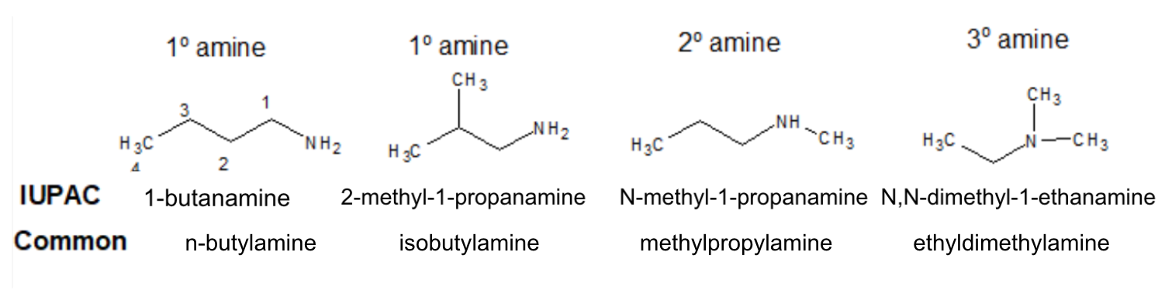
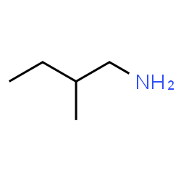 | 2-methyl butane-1-amine  1º amine
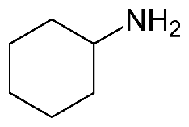 | Cyclohexaneamine  1º amine
Examples using the common names.

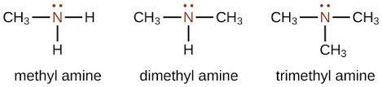
1º amine | 2º amine | 3º amine

More examples:

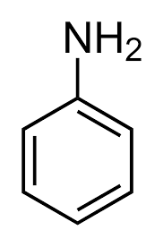 | 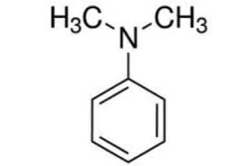
Aniline or phenyl amine | N.N-dimethyl N-phenyl amine  OR N,N-Dimethylaniline

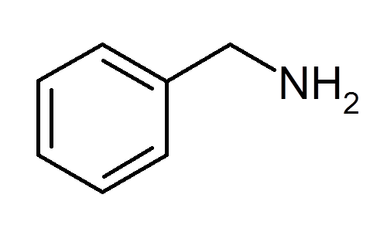 | 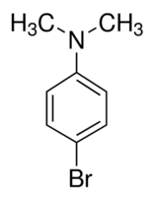
Benzyl amine | 4-bromo N,N-dimethyl aniline  N-(4-bromo phenyl) N,N-dimethyl amine

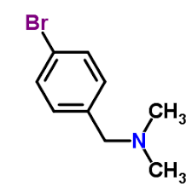
4-bromo benzyl dimethyl amine

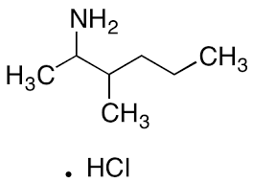 | 3-methyl-2-hexane amine  3-methyl hexane-2-amine

Amides: Link
An amide is a functional group that contains nitrogen connected to a carbonyl group. They may be primary, secondary or tertiary. The general structure of amides is shown below:

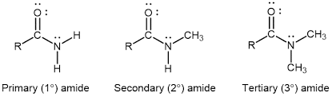
1º amide | 2º amide | 3º amide

Primary amides are named by changing the name of the acid by dropping the -oic acid or -ic acid endings and adding -amide. The carbonyl carbon is given the #1 location number. It is not necessary to include the location number in the name because it is assumed that the functional group will be on the end of the parent chain.

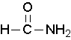 | methanamide or formamide
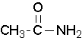 | ethanamide or acetamide
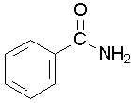 | benzamide
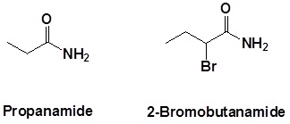
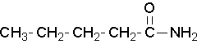
Pentamide
Secondary amides are named by using an upper case N to designate that the alkyl group is on the nitrogen atom. Alkyl groups attached to the nitrogen are named as substituents. The letter N is used to indicate they are attached to the nitrogen.
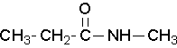
N-methylpropanamide

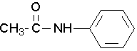
N-phenylethanamide or N-phenylacetamide
Tertiary amides are named in the same way as secondary amides, but with two N's
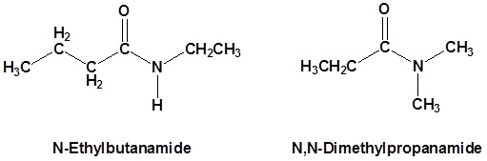
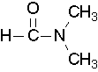
N,N-dimethylformamide
Examples:
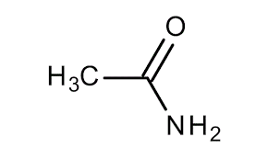 | 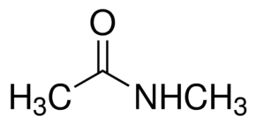 | 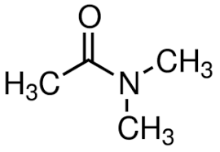
Acetamid, or  Ethanamide  1º amide | N-methyl Acetamide  2º amide | N,N-dimethyl Acetamide  3º amide
There are other functional groups that contain sulfur, and other elements, or with different collection of elements like ketene group, CH₂=C=O. They are out of the scope of this introductory material.
THE END
July 2021
Modified Dec 2021

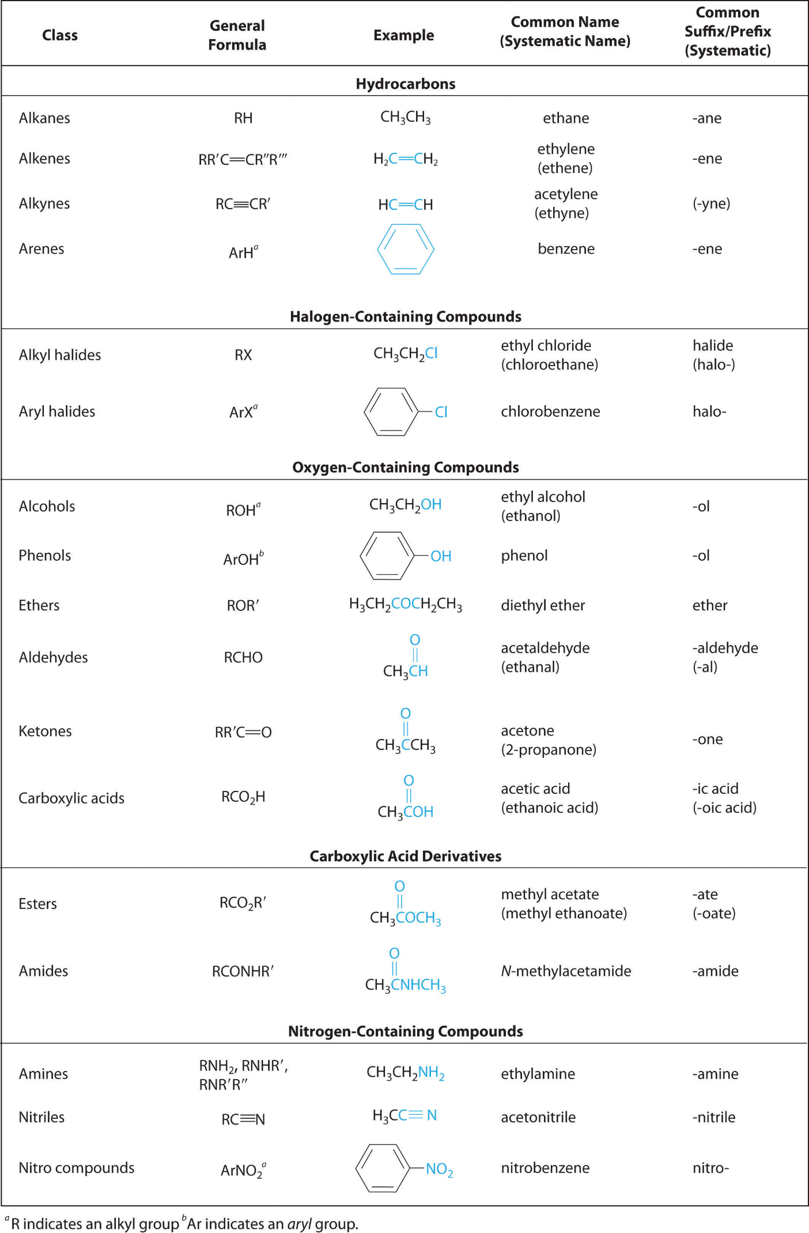
Representing the formulas of organic compounds:
Closed formula:
Expanded structural formula: Shows all atoms and bonds in the molecule.
Condensed structural formula: Shows only specific bonds. (Some of the C—H bonds are omitted).
Line-angle formula: Skeletal structures in which bonds are represented by line segments. Two lines are connected by an angle, which represents a carbon atom. The H’s on C’s are usually not shown.

Give Example

Hydrocarbon and Alkane Nomenclature:
Hydrocarbons are compounds that contain only carbon and hydrogen.
Saturated hydrocarbons contain single bonds only.
Unsaturated hydrocarbons contain multiple bonds (double and triple).

Give Examples

Alkanes:
They are saturated hydrocarbons. They can be cyclic or acyclic.
They have the general formula of C_{n}H_{2n+2} when the structure contains no cyclic parts.
The general formula for cyclic alkanes with only one cycle is C_{n}H_{2n}.

Give Examples

Nomenclature of Alkanes:

Cycloalkanes:

Common Physical Properties of Alkanes:

Reactions of Alkanes:

Chapter 1: Alkanes
Chapter 2: Unsaturated hydrocarbons
Chapter 3: Alcohols, phenols, ethers
Chapter 4: Aldehydes and ketones
Chapter 5: Carboxylic Acids and Esters
Chapter 6: Amines and Amides

