1 -diagnosis?
nodule
2- management?
speech therapy
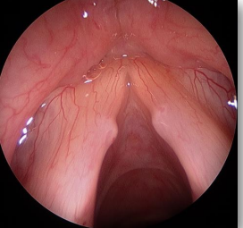

3- which of the following is wrong?
Maxillary polyp grow anteriorly
4- mx ? Systemic steroid then topical 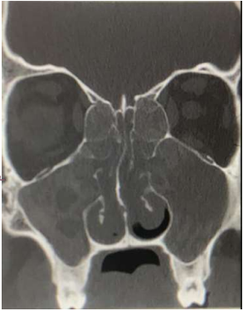

5- what is the name of test? Dix hallpike (image for dix hallpike)
6- if it was +ve, what is next? Canalith repositioning manuver

7- perforated ear)من الصورة تحدد انها يمين مش مكتوبة) one is true?
righ rinne negative left positive weber to right

8- which is true?
Tympanogram type B with high volume
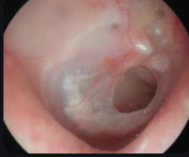

9- dx? quinsy
10- what is the most likely causative agent?
mixed flora
11- mx except ? Tonsillectomy
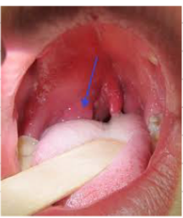

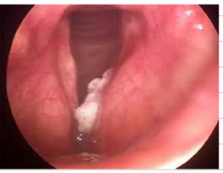
12 - laryngeal cancer for definitive dx? direct laryngeo + biopsy
13- Lc type is SCC

14- pure tone audiometry pic bilateral sensorineural HL
15- case of presbycusis so answer is 70 yo female
16- TYMPANO : Bilateral Type A
17- tx by hearing aid 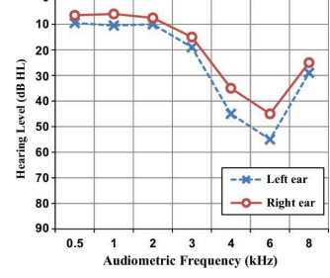

18- all are true about tracheostomy except ? Remove next day after surgery

19- bulge TM what is the mx : systemic anti biotic anti pyretic with analgesic with myringitomy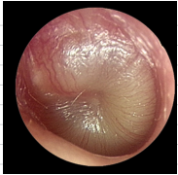
20-on tympanometry? air abnormal, bone normal ,with air bone gap

