Family Medicine Archive (Group C+D)

- Mention 4 skills a family medicine physician should have:

- 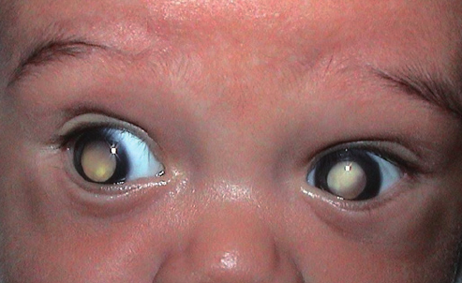
-What is this test called

-Mention 2 other screening tests for newborns

- [a case of a man complaining of chest pain that is relieved with rest]
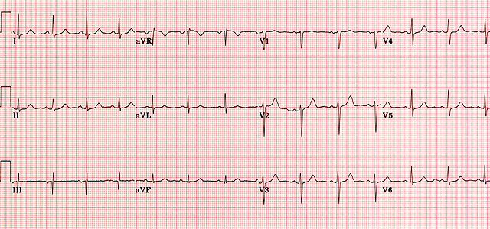
-what is your interpretation of the ECG: Normal ECG

-diagnosis: angina pectoris (stable angina)

- [a case of a 52 year old man, diabetic, LDL 160, with CVSD risk 18%]
-Management: Moderate intensity statin + Lifestyle modifications

- 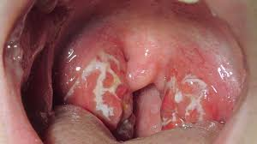
-Diagnosis ?
-Mention two indications for tonsillectomy?

- [A case of diabetic patient with nephropathy and hypertension]
-Treatment?
-What is the antidiabetic medication that is safe to use with chronic kidney disease?

- [a case of a woman with ovarian cysts, rebound tenderness, RLQ Pain..]
-Give four differential diagnoses.

- [an elderly female with asthma and gout]
-Most suitable antihypertensive.

- 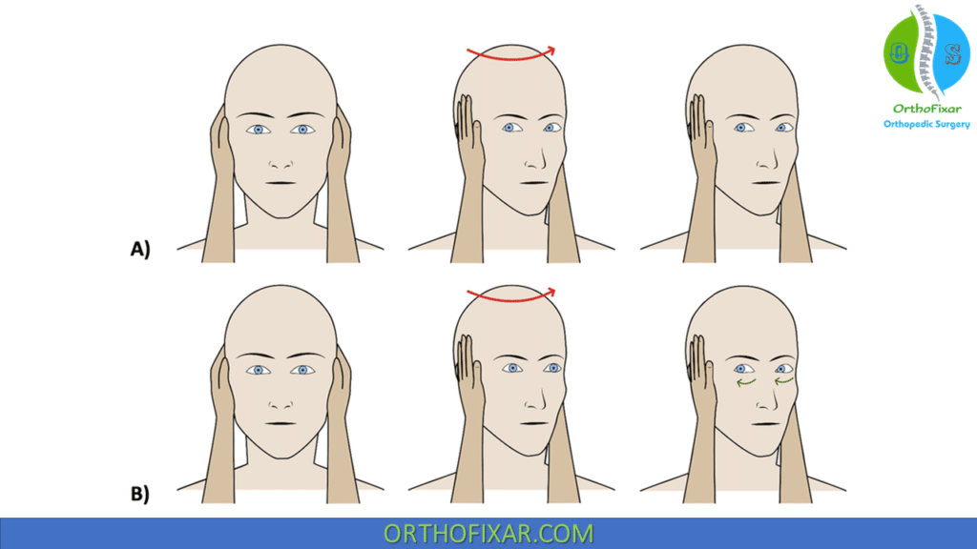
- Name of the test
- Diagnosis if the test is positive

- -A Katz index score (can’t remember the score), your indication for this patient:
-Mention 4 Activities of daily living

- [A typical case of migraine with prodroma]
-Diagnosis
-Do you use prophylactic treatment for this patient: yes
-Mention one prophylactic drug

- Mention (3 or 4 ) initial investigations for a fatigued patient
- Preventive measures for Osteoporosis

