Neurosurgery Archive (C+D)
[All the pictures in here are not the exact pictures, but the most close to them]
[MCQ]
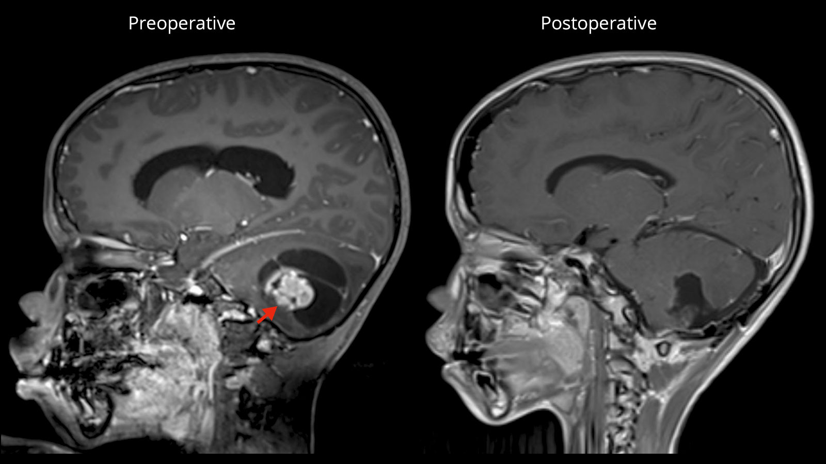

- A child with this radiograph, diagnosis: Pilocystic astrocytoma
- Type of the lesion: Cystic with mural nodule
- What does this radiograph shows: Obstructive (Non-communicating) hydrocephalus
- If the patient’s state was deteriorating, what is your management: EDV (اغلب حكوا هاي الصح)

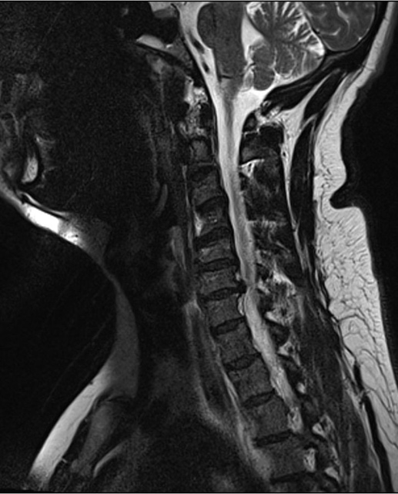 [A long case describing the patient’s signs and symptoms, but he had hyperreflexia, numbness in the forearm and the middle finger, and the elbow was moving on the bed sheet only…]
- Answer: Myelopathy with radiculopathy
- Treatment: surgery
- Level: C7
- Grade of elbow extension: grade 3

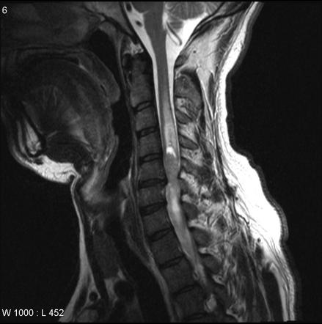 [pic was not the same and not sure of the answers]
1-Cells of this type of tumor: ependymal cells (?)
2- Management: surgery (?)
3-MC symptom with such tumor: back pain (?)

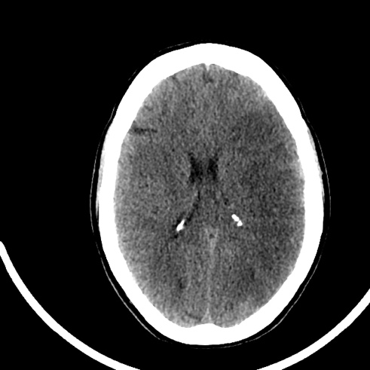
[A long case of a man that has been in an RTA, came to the ER after 3 hours in a coma, no head trauma detected, BP (?/?) (was low)…..]
1-What does this CT (near the pic above) indicate: Cytotoxic edema
2- What caused it? Ischemia (the cause of cytotoxic edema )
3-what type of shock did this patient experience: Hemorrhagic shock
4-What would you treat this patient based on his initial presentation: Hypertonic saline 23%

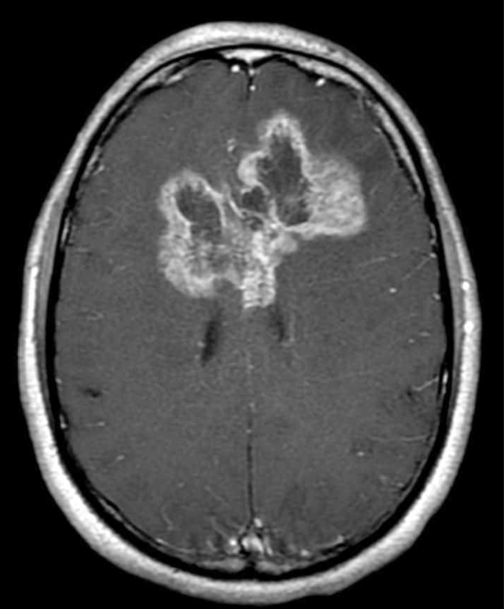
1-Histological: pseudo palisading and central necrosis
2- treatment: Surgical then chemotherapy then radiptherapy
3- symptoms: headache/ seziures/ hemiparesis/ (all of the above)
4-One of the following will mostly be associated with abscess but not glioblastoma: Renal disease/ dialysis

