2016 mini OSCE
- CT scan kidney stone ..treatment
treatment
- Medical ( NSAIDs > opioid >>Ca CHANNEL ANTAGOINST >> antiemetic >> ALPH BLOCKER IN LOWER )
- Shock-wave lithotripsy (SWL)
- Ureteroscopy.
- Percutaneous nephrolithotomy (PCNL).
- Open Stone surgery

- Hypospadia..type?..embryology
Glandular …proximal penile …mid shaft … distal penile , scrotal …perineal
The end of 3rd month ,(incomplete closure of urethral folds on the underside of the penis during
embryological development) endoderm
- Ultra sound filling defect 5 DDX ,,,Bladder cancer surgery for T2
Ddx … neoplasm
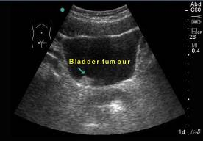
stone
blood clot
enlargement prostate gland
fungal ball
focal cystitis
-Radical cystectomy

- Pic of Folyes catheter?
-indication of catheterization>>
1.Urinary retention
2.Obstruction of the urethra prostate cancer)
3.Collection of a sterile urine specimen for diagnostic purposes
4.After surgery.
5.Intra operative
6.Uorodynamic study

-indication for 3 ways catheter :
1. after bladder/ prostate surgery (to wash-out blood and clots that block the
catheter)
2. Cases of gross hematuria
3. Bladder infections
-Name the absolute contraindications for the insertion of these tools >>
1- urethral tear
2- pelvic fracture
3- urethral trauma
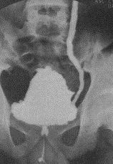
- Pic of vesico uretric reflux ? Indication for surgery
1-If it is not possible to keep the urine sterile and reflux persists.
2-If acute pyelonephritis not responding to treatment
3-If increased renal damage
4-High grade reflux (grade IV or V - not an absolute indication)

- PSA defintion and function
is a glycoprotein enzyme produced by prostatic epithelial cells. and its function is to liquefy the ejaculate, enabling fertilization

- Complete the blanks :
The most common location for undesecended testis is (1) Prepubic and the age at which the operation should be performed is (2) 1 year
In the prostate gland, the most common location of BPH is (3) Transitional zone And the most common location for a prostatic cancer is (4) Peripheral zone
In UTI: Infection by a different baceteria is termed (5) Reinfection while
infection by the same organism from a focus within the urinary tract is termed (6) Bacterial persistence . Compliance describes the relationship
between (7) volume & (8) pressure . The spinal shock following severe injury to the spinal cord lasts (9) 3 months During this period, the bladder is
(10)hypoactive(flaccid)

- Definition of each type of stone
Calcium Stones (most common ) Composed of either Calcium oxalate or phosphate Radio-dense (i.e. visible of abdominal radiograph) Occurs secondary to hypercalcuria (more common) and hyperoxaluria
Uric Acid Stones (2nd most common) Radiolucent (cannot be seen on abdominal radiograph) Causes Associated with Hyperuricemia.(gout)
Struvite Stones (Staghorn stones ) Radio-dense (magnesium ammonium phosphate) Causes Often seen in patients with recurrent UTI’s due to urease producing organisms (such as Proteus and Klebsieilla)
Cystine stones (rare) radio-lucent Seen in patients with Cystinuria (autosomal recessive)

- KUB picture
- identify the pictures >> KUB
- differences between KUB and abdominal X-ray >> 1- from xiphoid to suprapubic
2- psoas shadow is seen 3- needs preparation 4- Usually supine 5- hyper exposure
- most common type of renal stones >> Calcium oxalate

- picture of urethral stricture
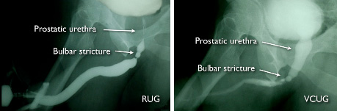
- identify the part of the urethra shown : bulbar
- diagnosis : urethral stricture
- causes : iatrogenic , tumor , stone , trauma

- Matching
- patient with prostate size 40g and bothersome symptoms Tx is>> alpha blocker
- patient with prostate size 100g and large bladder stone >>tranvesical prostatectomy
- patient with localized prostate CA>> Radical prostatectomy
- patient with metastatic prostate CA>> molecular therapy
- patient with prostate size 80g without symptom >> watchful waiting

- patient with car accident with incontinence:
- type of incontinence >> overflow
- causes of it >> spinal cord injury
- bladder function after 3 months >> overfunction

- essay question
- define the erectile dysfunction >> (is the inability to achieve and maintain an erection adequate for intercourse to the mutual satisfaction of the man and his partner.)
- differences between organic and psychological types >>
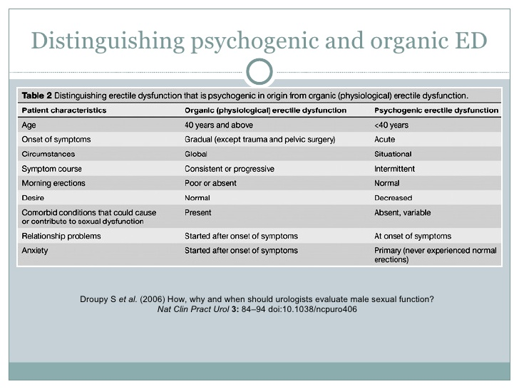
- mechanism of sildenafil function >> (Mechanism of Action: Viagra >> PDE inhibitor and increases the cGMP that promotes and sustains smooth muscle relaxation)
- Psychogenic Causes: Anxiety ,Depression, Fatigue ,Guilt, Stress, Marital Discord, Excessive alcohol consumption

- smoker patient with bladder mass
- the first investigation of choice : cystoscopy
- most common cancer of the bladder is : TCC
- can you do suprapubic catheterization in this case and why ?
No , because this make the cancer to spread

- identify the picture >> three way foley catheter
- why we use it in prostate cancer >> for irrigation ( in bleeding )
- the best solution to fill it in this catheter is >> sterile water or normal saline

- KUB with double J catheter
- identify the pointed structure >> Double J catheter
- mention 3 indications>>
1- Relief of obstruction
2- Prevention of obstruction
3- after the ESWL
4-Post-renal transplantation
5- Malignancy

- VCUG showing bilateral VUR, the baby was diagnosed with antenatal hydronephrosis, what else should you suspect in him?
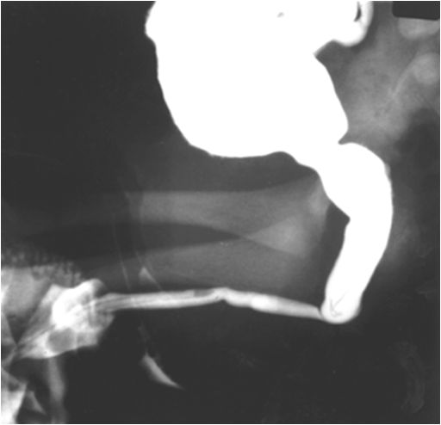
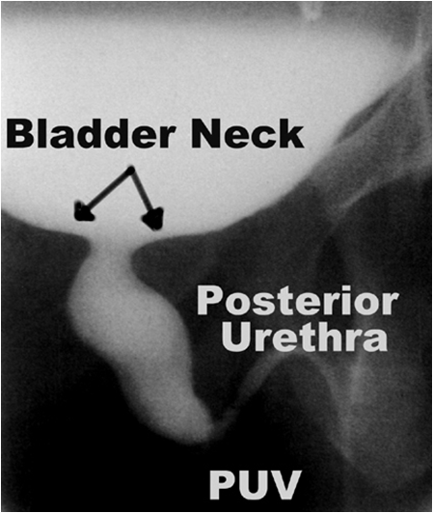
-HYPERTENSION , failure to grow .

- CT showing renal cancer, identify
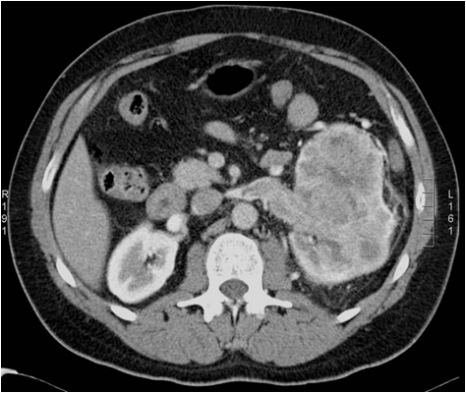
left

-Mention 3 clinical presentations>>
flank pain, palpable mass, gross hematuria
- mention investigations you should preform to check for mets >> cystoscope, bone scan, chest xray)

- Renal vascular trauma, which grade? Management? Indication for surgical exploration
Grade 1: (most common): Renal contusion or bruising of the renal parenchyma.
Grade 2: Renal parenchymal laceration into the renal cortex.
Grade 3: Renal parenchymal laceration extending through the cortex and into renal medulla.
Grade 4: Renal parenchymal laceration extending into the renal collecting system, main renal artery thrombosis, segmental renal vein, artery , or both with contained bleeding.
Grade 5: Multiple deep parenchymal lacerations, renal pedicle avulsion, or main renal vein or artery injury( penetrating trauma).

- 68 year old male patient with bph came to the ER with back pain, abdominal pain and he didn’t pass urine since morning , diagnosis? What exam do you do to support the diagnosis? What investigations? One important thing in the management
-Exam >>palpate suprapubic area to determine if there is urine retention or anuria -investigation >>PSA ,urinanalysis ,creatinine
-management >>foleys catheteration

Past questions

- An IVP image showing a left non functioning kidney (no contrast excretion), right hydronephrosis and a filling defect in the bladder
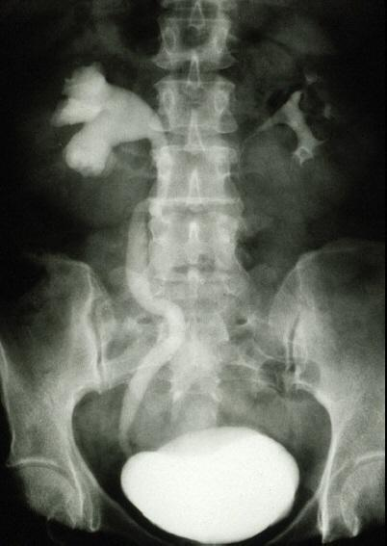
-Name 3 radiological abnormalities

- This is KUB of a 37 year old female patient with a history
of loin pain and recurrent UTI. This patients has 2 kids
-what is the most probable etiology for her condition>>
Infection(proteus,pseudomonas, Klebsiella)
-What is the composition of this pathology>>
Magnesium ammonium phosphate
-What is the most appropriate method of management>>
PCNL (percutaneous nephrolithotomy)

- For each of the following conditions, write the most
appropriate method of diagnosis:
-renal scar >> DMSA scan
- renal cyst >> US
- renal stone >> CT
- VUR >> voiding cystourethrogram
- pelviureteric junction obstruction >> CT

- For each of the following, write down the most appropriate method of treatment:
A-8mm diameter mid ureteric stone >> eswl (shouck wave lithotripsy )
B- 13mm stone in the mid renal calyx.>> uretroscopy (intracorporal)
C- solitary, exophytic T1 transitional cell carcinoma of the bladder >>TURBT
D- BPH with bothersome urinary obstructive symptoms.>>alpha blocker
E- advanced prostatic adenocarcinoma with bony metastasis >> molecular therapy

- A 37 year old businessman presented with flank pain, high fever and chills. He has been started on gout medication since 2 months
-what is the most probable diagnosis>> urinary tract stone ( uric acid )
-what investigations you would like to order >> raidiological (non contrast CT scan , IVP , Retrograde pyelography , Renal Ultrasound ) . Urinalysis . CBC . KFT.
-what is medical treatment >> hydration , urine alkalinization , Allopurinol , dietary manipulation
-if stone in bladder >> potassium citrate

- What is the name of this test >> transillumination test
-What is the diagnosis >> hydrocele
-Management>> children >> resolve spontainuosly
In adult >> surgical excision
If secondary >> treat underlying cause

Mini OSCE 2013

- What is the name of this condition >> Cryptorchidism ( undescended testis )
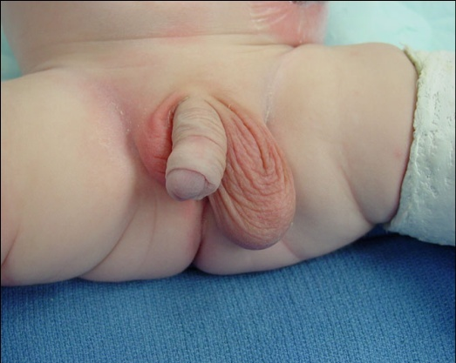
-What is the procedure performed, and when >> orchidopexy…..when>> after 1 year (6-18 months )
-List 5 complications associated with the condition >> hypoinfertility , cancer , torsion , trauma , inguinal hernia
-investigation >>chromosome analysis and hormone test

- What is the diagnosis >> Torsion
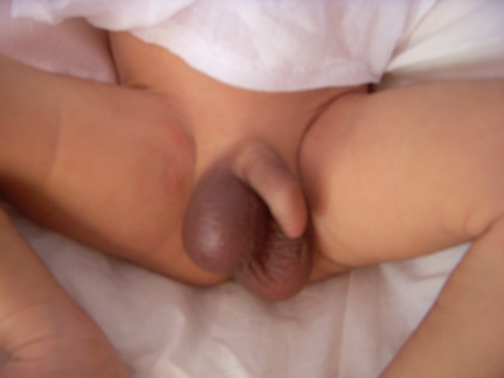
-What method of investigation is helpful in this situation >> color Doppler US
-What is the treatment >> surgical exploration , untwist testis and orchidopexy

- What is the name of this procedure>> Transuretheral resection bladder (TURB)
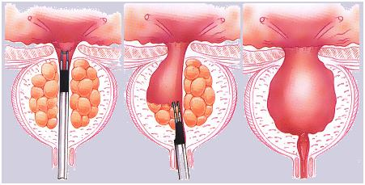
-What are the complications>> perforation of the bladder , sepsis, incontinence , ureteral stricture , hemorrhage , incomplete resection .

- Choose the correct answer :
-Tumescence is mediated by>>
a. Thoracic sympathetic
b. Pelvic sympathetic
c. Lumbar parasympathetic
d. Pelvic parasympathetic (Correct Answer)
e. Sacral somatic

- What is the name of the radiological abnormality shown? (Additional CT Image was present in the exam) >> Hydronephrosis
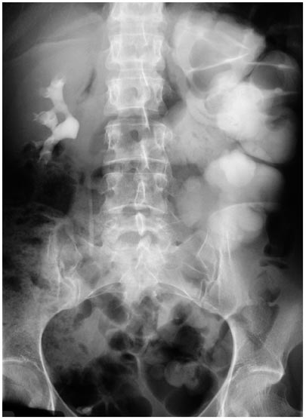
-List 5 causes >> Kidney stones , BPH , pregnancy ,
narrowing of the ureters , neurogenic bladder

- Describe the radiological abnormality seen>> Bladder Filling Defect
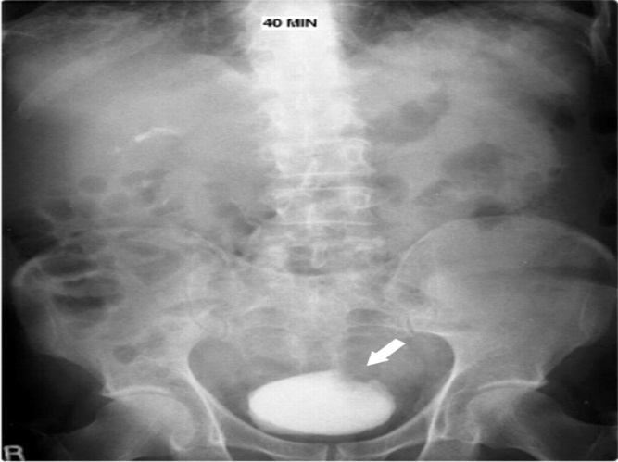
-List five differential diagnosis >> Blood clot , stone , Neoplasm , Polyp , Prostatic enlargement , focal cystitis

Mini
- Routine PSA examination yields PSA level of 8ng/ml
-Causes of increased PSA>> benign prostatic hyperplasia, prostate cancer, acute prostatitis, UTI , ejaculation , DRE , biopsy , TURP

- Lady with loin pain & history of stone formation (has been removed)
-Indications for admission>> intractable pain, toxemia suggesting infection, bilateral urine flow obstruction, single kidney & renal failure

- X-ray of staghorn stone
-Diagnosis>> struvite stone (due to infection)
-Management>>PCNL (percutaneous nephrolithotomy)

- Newly married female with typical presentation of UTI: fever, frequency, urgency … etc
-Simple diagnostic tests>> urine analysis, urine culture & sensitivity test & CBC

- Patient with spinal injury & quadriplegia cannot pass urine & has urinary incontinence
Diagnosis>> spinal shock
-Type of incontinence>> overflow incontinence (bladder is hypoactive)
-Predict bladder & sphincter function after 3 months>> bladder becomes hyperactive + detrusor sphincter dyssynergia (DSD)

- A 65-year-old male patient presented to you complaining of red colored urine. What are the main questions in history that you will ask
Timing of macroscopic hematuria in urinary stream

- While taking a shower, a 24-year-old male patient noticed a painless mass in his scortum. He is a smoker since 10 years. Answer the following questions:
-What are the points in this history that goes with a diagnosis of testicular cancer>>Painless mass …smoker 10 years ………age 24
-Name the investigations that will help you reach a diagnosis>> US , tumor markers (alpha fetoprotein, HCG , LDH and PLAP).
-What is the treatment >>1)Radical inguinal orchiectomy (Dx & local control)
2) radiotherapy

- A 50-year-old male patient presented with hematuria. He has been a worker in a chemical factory since 25 years. Answer the following questions
-What is the main finding in this IVP>>Raidiolucent filling defect projecting in to the lumian ( bilateral hydronephrosis)
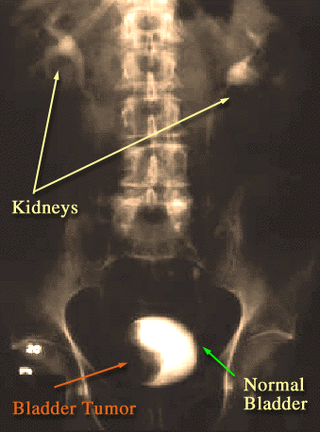
-If this patient was found to have a low grade bladder tumor,
what is the management>> TURBT ( transuratheral resection
of bladder tumor )
If invasive : radical cystectomy + pelvic lymphadenectomy
If metastatic : chemotherapy + radiation

- If a child has testicular torsion, name 3 signs that you will find during physical examination
-ve Prehn’s sign, retracted testis, and absent cremasteric reflex

2017 mini OSCE
- What is the PSA
- Function >> to liquefy the ejaculate, enabling fertilization
-Five thing lead it to increase >> benign prostatic hyperplasia, prostate cancer, acute prostatitis, UTI , ejaculation , DRE , biopsy , TURP

- KUB indicate a stone in the left ureter
- what's the difference between the KUB and normal abdominal Xray>>
1- from xiphoid to suprapubic 2- psoas shadow is seen 3- needs preparation 4- Usually supine 5-hyper exposure
-What's the composition of the stone in pic>> calcium oxalate
-What's the best management for it >> medical > I.V fluid , NSAIDs , alpha blocker

- CT scan show bladder cancer and history of gross hematuria
- write the most likely diagnosis for it>>bladder CA
-the most likely risk factor to get it >> smoking
- The T stages for any bladder cancer in general>>
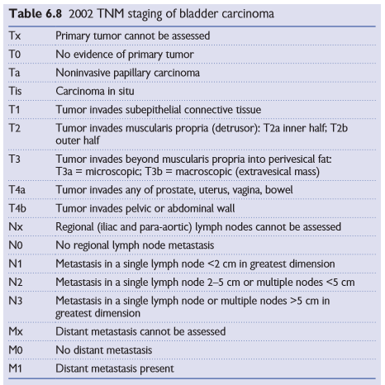

- define all the following
- Radical cystectomy >>remove bladder + prostatic urethra + distal ureter + regional LN
-Radical nephrectomy >> remove kidney +/- LN +/- perinephric fat + upper half of ipsilateral ureter
-most common site for metastasis in testicular cancer >>para aortic lymph nodes , lung /prostatic tumor>>bone

- CT scan showing kidney tumour
- Mention 5 symptom of disease and 2 name of syndrome the disease made>>
Haematuria , flank pain , mass , bone pain, night sweats
Von Hippel–Lindau (VHL) syndrome , Birt-Hogg-Dubé (BHD) syndrome
-Your diagnose >> renal cell carcinoma
-what is gold standard investigation >> CT with contrast
- What are the gold standard of management>> radical nephrectomy

- history of 65 year old man with long standing lower back pain and with no urine pass since morning
- what are the clinical examination that you will perform and the finding that support your diagnosis >> palpate suprapubic area to determine if there is urine retention or anuria
-what's the first line of management >> insert folyes catheter
- pic showing a black necrotic right testis
- describe what you see >> swollen and black testis , pulled up testis
-which age affect and what's the peak age >> (10-30 years ), (peak is 13-15 years)
-mention 3 arteries supplying the tests >> testicular artery , cremastric artery , Artery of the ductus deferens
-mention the thing that fixes the tests in it's position >> spermatic cord
-What happen if untreated >> infarction and die

- true or false
-Absorption of ca mainly in jejnium and proximal ileum >> F .. (duodenum)
- the male to female ratio in bladder ca is 3:1 >> T
- Stone formation may be a genetic cause >> T
-gallbladder stone have an increased risk factor for renal stone >> T
- The lymphatic spread of testicular cancer is mainly to iliac lymph node>>F
The end
Done by :
Noor Daher Alhijjaj

