- 🔴Epithelium and side of ulcer ➡️margin
- 🔴Tethring ➡️dimbling
- 🔴PVD MC ➡️atherosclerosis
- 🔴Piiting oedema except ➡️Lymphatic
- 🔴The end of bed ➡️abdominal symmetry
- 🔴Retrosternal chest pain expet ➡️Osephgeal rupture 2-pulmonary embolism 3_angina
- 🔴Hematmesis ➡️vomiting coffe ground?
- 🔴Spleeomegaly expet ➡️start to examin from LIF
- 🔴Normal palable in abdominal examination ➡️inguinal lymph node
- 🔴Cause of dullness expet ➡️Intestinal obstruction [resonance due to swallowed air]
- 🔴Brest risk factor most important ➡️1-gentic 2_being female 3.age
- 🔴20 y female her mother dX with breast cancer at 31 died and her sister Dx at 29 most implications ➡️signifiacane associated with cancer
- 🔴PVD chronic state ➡️Paralysis
- 🔴Man with previous DVT in Right Leg now has ulcer Irregular edge ➡️ sloping edge [venous ulcer mean heal ]
- 🔴All cause of increase 1st heart sound expet ➡️LOng PR interval
- 🔴All are true except ➡️penmonia and plural effusion cause Increas vocal resonance [effusion decreased]
- 🔴Jaundice wrong ➡️uncojugated cause clay stool with dark urin
- 🔴Wronge statement ➡️Mitral regurgitation cause ejection systolic murmer[mini osci open snap with mitral stenosis in mid diastolic murmer]
- 🔴Radio femoral delay ➡️aortic coartication
- 🔴Mennorhgea ➡️80 ml
- 🔴Normal beat ➡️60_100
- 🔴Central cyanosis except ➡️left to right shunt [any thing cause increase in deoxyhemoglopin concentration cause cyanosis]
- 🔴TRUE statement ➡️transmitted Thrill moderate to sever
- 🔴2ry dysmenorrhea ➡️endometriosis
- 🔴Cripitation [crackles] in ➡️
- 🔴All associated with infective endocarditis except ➡️kolionychia [spoon shape associated IDA]
- 🔴Consual reflex ➡️pubel contraction when light in other pubil
- 🔴Cant breath when lying flat *supine *➡️Orthopnea
- 🔴Dyspnea awake from sleep ➡️paraxomal dyspnea
- 🔴Unilateral pubil dilitation not response to light ➡️occlumotor nerve palsy?? (true is optic nerve )
- 🔴Not cause splenomegaly ➡️SCA
- 🔴Intermittent claudication ➡️??????
- 🔴All cause wheeze expet ➡️
COPD
Bronchial Asthma
Heart failure [بتعمل]
Pulmonary fibrosis اظن الجؤاب
- 🔴Felling Thrill ➡️grade 4 murmer
- 🔴Loud with Thrill ➡️grade 4
- 🔴Thyrotoxosis most system affected ➡️ (according to the doctors its CVS
- 🔴Drug induce Cough ➡️angiotensin inhibtor [ABE I we will replace it by ARBs to devoid SE]
- 🔴Druge induce syncope except ➡️Beta agonist [which cause Palpitation]
- 🔴TRUE about JVP ➡️decreased with inspiration
- 🔴Wrong about JVP ➡️raped outward movement
- 🔴Site to hear pulmonary valve ➡️2ed left sternal border
- 🔴TRUE ➡️milking test for IVC and portal HTN
- 🔴Abdominal rigidty ➡️diffuse peritonitis
- Vision test 20/30 mean ***
- Radiology ***true is :MRI is non compitable prothesis
- Symptoms of hyperthyrodisim exept : constipation
- Intraabdominal fluid : shifiting dullness
- Not a tip of health : express hand gestures
- Internal jugular nerve BECAUSE :valve less
- All true about spleen expet :ballotable test مو متأكدة لو اجا بالحرفية
- Something you do :explain your roll
- Something you not to do :asking about personality problem
- Obese :30-39
- All cause systolic Murmer expet :Austin flint murmer
- Thyroid swelling true : movable with swallowing ?????
- Mediastinal mass expet : carotid bruiti[I guess its should be thyroid brui] ?????
- Wronge statement.. Liver Upper edge in mid axillary [true mid clavicular]
- ALL in PT profile except ➡️Social habiut
- Stereotyping meaning
- Best hearing with diaphragm ➡️1st and 2ed
- PVD risk factor ➡️Female?
- Motor except ➡️vibration sence
- Difference between vesicular breathing and Bronchial breathing
- Trachal deviation
- ALL are sign of infection expet ➡️coldness peripheral
- Wronge about JVP ➡️has one peak
- Barrel deformity definition
- Wronge statement ➡️Positive burger test mean pallor
- Hirstusm not by ➡️liver disease
- Arterial pulse normL Range باقي الخيارات وصف للشرايين (جمل خطأ)
- Jvp raises with abdominal pressure
- Jvp above the sternal notch normal by 9 cm
- S3 and S4 statement

- U
- U
- U
- 4

Mini osci
- goiter associated with all except :
Iodin defecioncy
Thyrotoxicosis
Malignancy
Pregnancy "✖️✖️✖️✖️✖️
Malnutrition
- name :
Peudo orange

- the floor of this ulcer :
Muscle and tendon ✖️✖️✖️✖️✖️
Blue tissue
Healthy granulation tissue
Gangrne tissue

- causes :
Lipid deposition .

- name : Cornea arcus
- area of auscultation :

Tricuspid valve

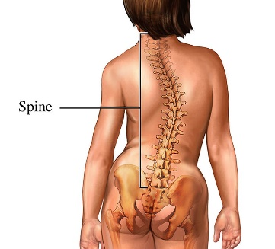
- name :
scoliosis

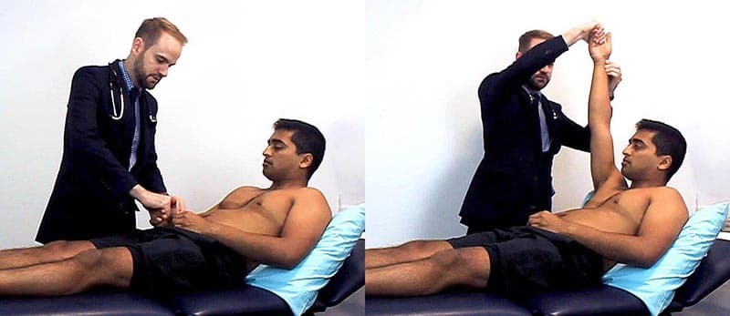
Collapsing pulse

- flapping tremor in all expet :
Hyperglycemia (ل حتعمل co2 retention by cause Komsomol breathing due to acidosis by lactic acid ) ✖️✖️✖️✖️✖️
Alcohl

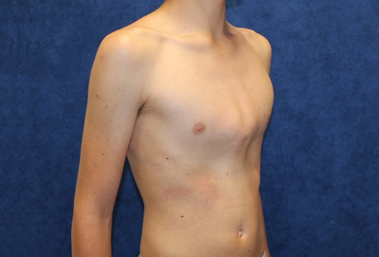

Pectus carinatum

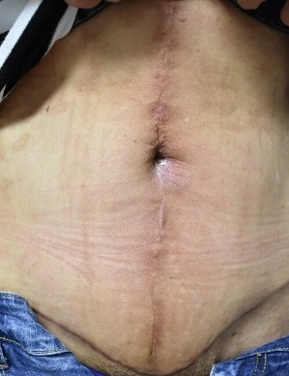
- شبه الصورة وطالب اسم insicion
Midline inscion

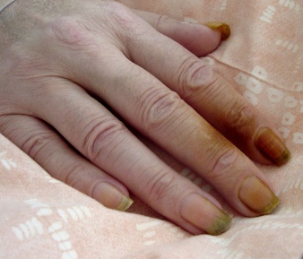
- :
Nicotin staining

- :shifiting dullness

- Trachal deviation

- vitiligo .

- marfan syndrome

- melanoma

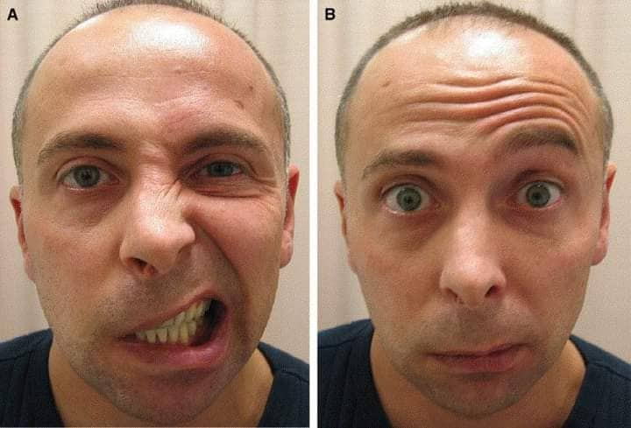
- 7th nerve pulsy

- gynachomastisia associated with liver cirrhosi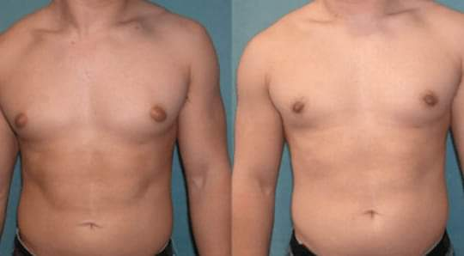s

- 15 sec 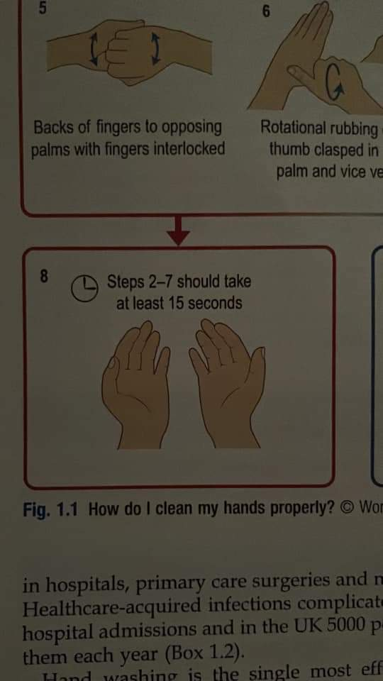

22_left sternoclidiomastoid

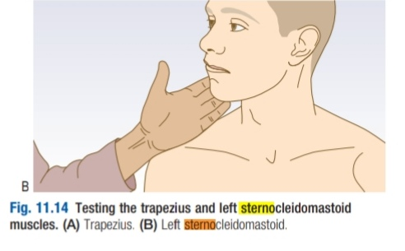
23_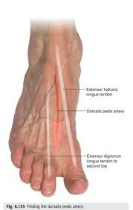
Dorsalis pedice artery and extensor hallucis longus
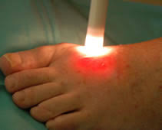
24_ transillumination test

25 _
Jaundice associated with expet :
PAncreatic
Cholengitis ✖️✖️✖️✖️✖️

26_ venous ulcer 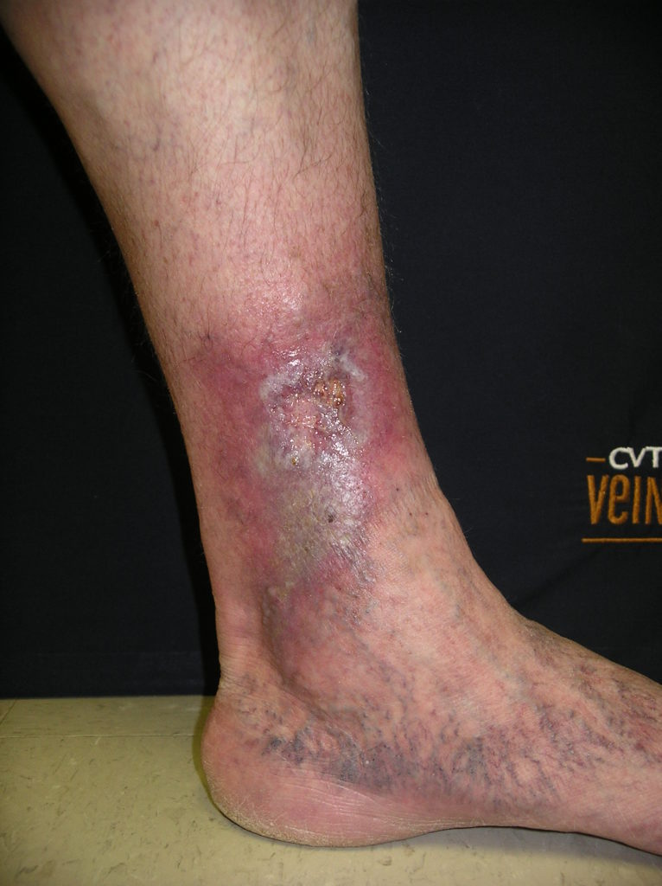
27_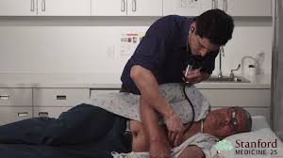
TRUE about
Mid diastolic murmer associated with open snap
28_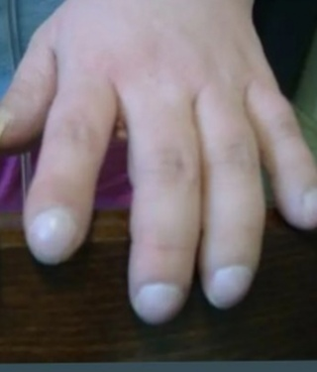
Not cause by chronic bronchitis
29_cynosis :anemia is difficult to seen
30 _symptoms associated with arterial ulcer exepet :granulation

